EXPERIMENT 05
PERFORM WEB SERVER RECONNAISSANCE USING VARIOUS TOOLS

1. AIM
To identify web server software types, exact build versions, operating system details, and configuration vulnerabilities using Nmap, Nikto, WhatWeb, and curl.

2. THEORY
Web server reconnaissance establishes the technical specification of the web hosting infrastructure.
Identifying exact version numbers allows security analysts to check vulnerability databases (CVE/NVD) for known unpatched exploits applicable to that target build.

3. TOOLS REQUIRED
- Nmap
- Nikto Scanner
- WhatWeb
- curl CLI
- Target Server (Metasploitable2 / Apache)

4. PROCEDURE & COMMANDS
Step 1: Perform Nmap Service & Version Detection
Scan HTTP/HTTPS ports to identify web server software and operating system details:
nmap -sV -p 80,443,8080 <target-ip>

Step 2: Run Nmap Web Enumeration Scripts
Use Nmap Scripting Engine (NSE) to extract server banners and HTTP headers:
nmap -p80 --script=http-headers,http-title,http-server-header <target-ip>

Step 3: Manually Inspect HTTP Response Headers
Fetch raw HTTP header metadata using curl:
curl -I http://<target-ip>

Step 4: Execute Fingerprinting with WhatWeb
Gather complete tech stack details (CMS, frameworks, server OS):
whatweb http://<target-ip>

Step 5: Run Automated Vulnerability Scan using Nikto
Scan the web server for dangerous files, outdated builds, and missing security headers:
nikto -h http://<target-ip>

5. LAB OBSERVATIONS & OUTPUT SCREENSHOTS
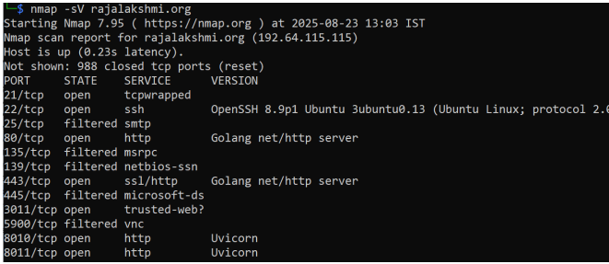

6. EXPECTED OUTPUT RESULT
A complete web server fingerprint documenting software versions (e.g., Apache 2.2.8 Ubuntu), open ports, exposed headers, and Nikto security findings.

7. VIVA VOICE QUESTIONS & ANSWERS
S.NO & VIVA QUESTION | TECHNICAL ANSWER
Q1. What is the purpose of the -sV flag in Nmap? | It enables service version detection, probing open ports to determine exact software names and version numbers.
Q2. Why is the Server: HTTP header useful to an attacker, and how can an administrator hide it? | It reveals exact server binaries and versions. Administrators hide it by setting ServerTokens Prod in Apache or server_tokens off in Nginx.
Q3. What kind of issues does Nikto specifically look for? | Nikto checks for 6,700+ dangerous files, outdated server software, default index files, insecure HTTP methods, and missing security headers.
Q4. What is the difference between WhatWeb and Nikto — do they do the same job? | WhatWeb identifies CMS and technology stack components. Nikto scans specifically for server misconfigurations and known vulnerabilities.
Q5. Why is it important to identify the exact web server version before performing further testing? | It allows targeted searching of CVE databases for specific, tested exploits applicable to that exact build version.

